**LAB # 4**

**“Implementation of single Layer perceptron with Optimizer”**

**OBJECTIVE:** Implementation of single Layer perceptron with Optimizer.

**LAB TASKS:**

**Task 1: Change the Activation Function**

See how activation functions affect predictions. Try changing from 'sigmoid' to 'relu'.

**CODE FOR SIGMOID:**

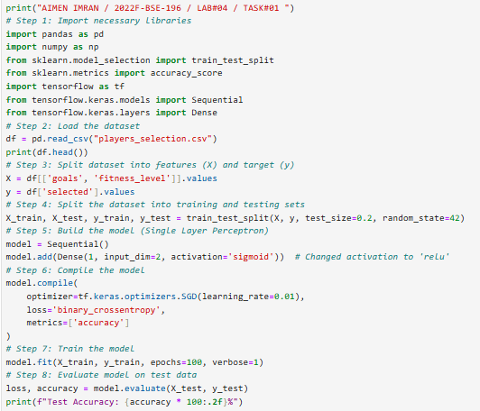

**OUTPUT:**

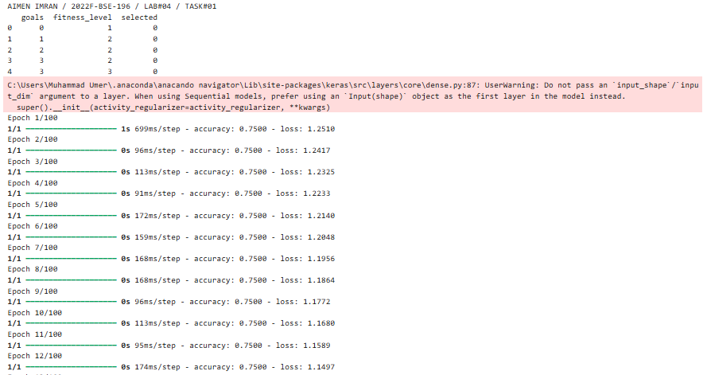

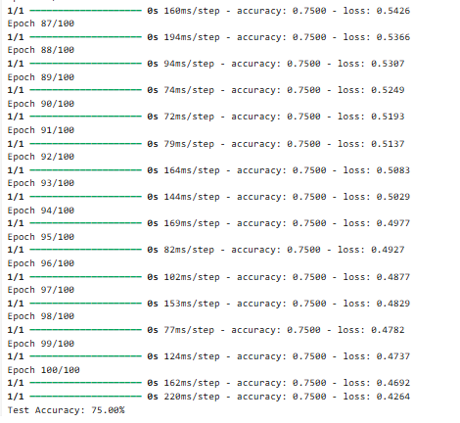

**CODE FOR RELU:**

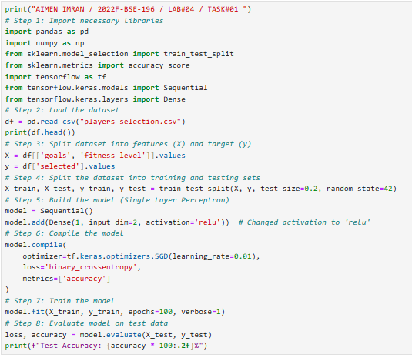

**OUTPUT:**

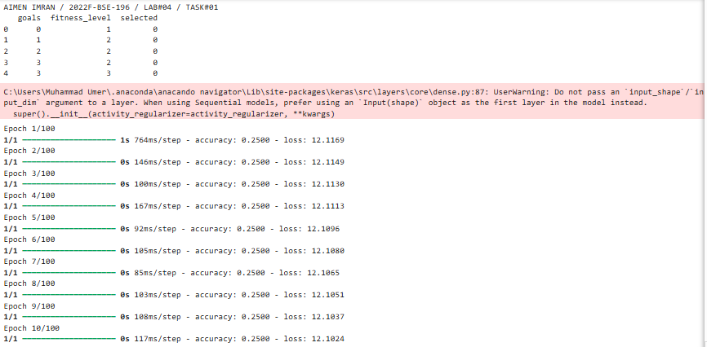

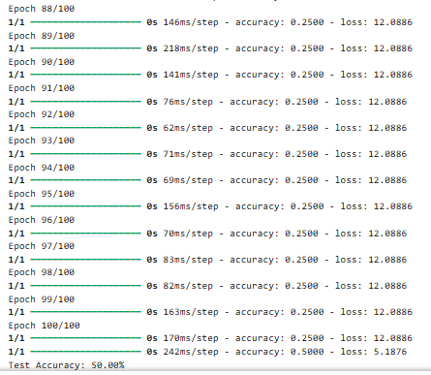

**Task 2: Add One More Hidden Layer**

Understand how hidden layers increase the model’s learning power

**CODE:**

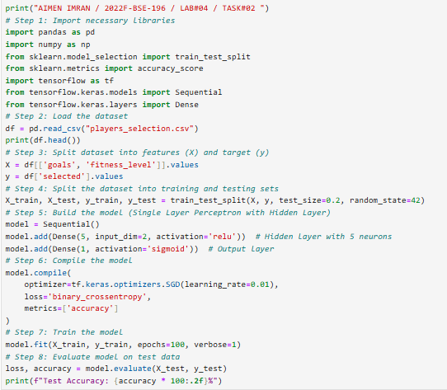

**OUTPUT:**

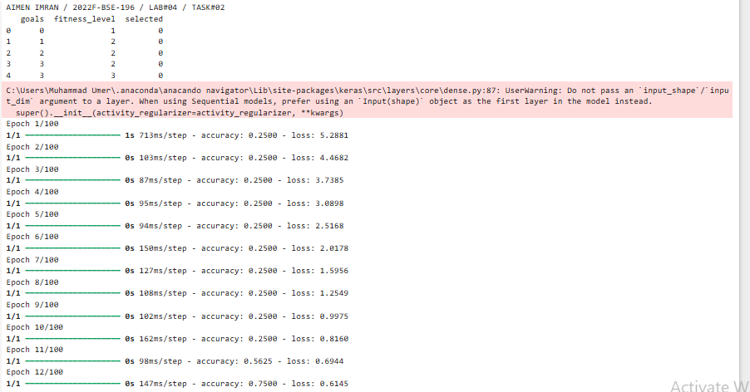

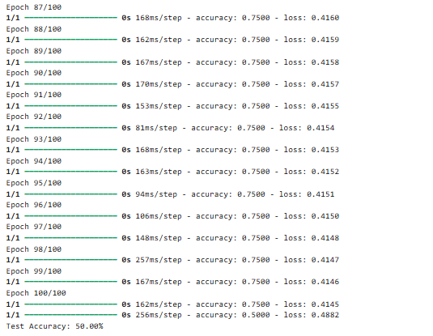

**Task 3: Add More Neurons**

See how increasing neurons changes learning capacity

**CODE:**

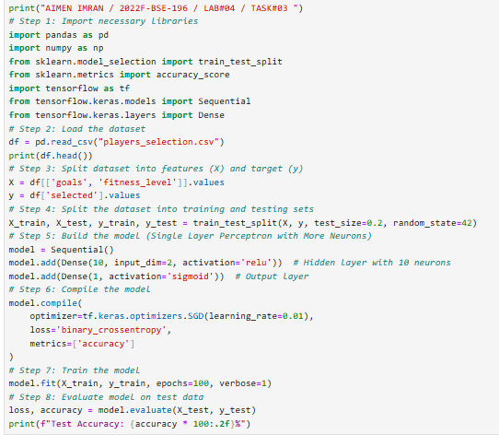

**OUTPUT:**

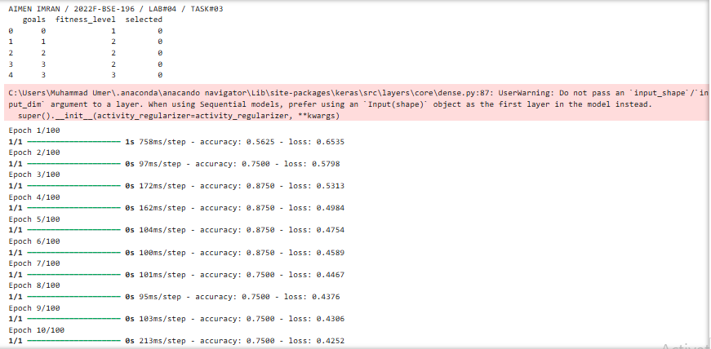

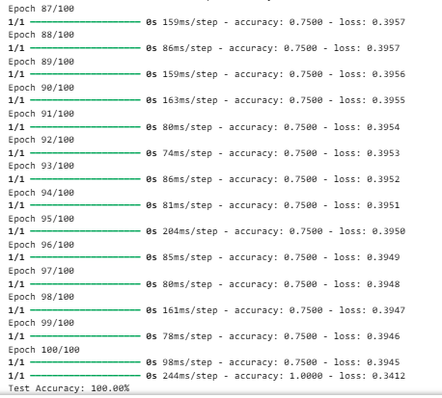

**Task 4: Compare Loss and Accuracy**

After each task,:

• Print training accuracy

• Print model predictions on test data

• Observe and compare changes

**CODE:**

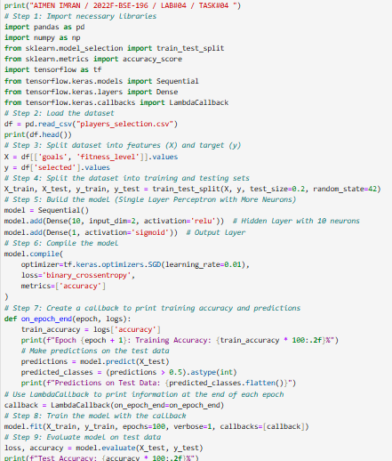

**OUTPUT:**

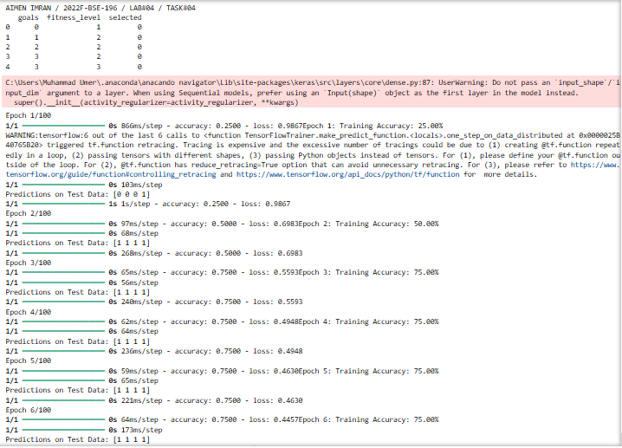

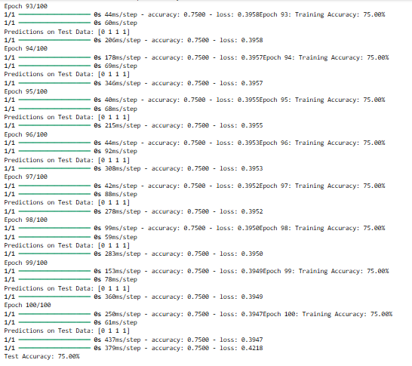

**GITHUB:**

**KAGGLE UPLOAD:**